Ex. No. : 02A Date: 14-02-2026
Register No.: 231701023 Name: S.V.Jashwanth

Basic Calculator
Aim
To develop a basic calculator Android application using Android Studio and Kotlin to perform simple arithmetic operations.

Procedure:

- Open Android Studio and create a new project with an Empty Activity.

- Select Kotlin as the language and complete project creation.

- Design the layout with two EditText fields, one TextView, and buttons for arithmetic operations.

- Open MainActivity.kt and connect UI components using findViewById.

- Write code to perform addition, subtraction, multiplication, and division on button click.

- Display the calculated result in the TextView and show a Toast message for the operation performed.

- Run the application on an emulator or mobile device and verify the output.

AndroidManifest.xml

<?xml version="1.0" encoding="utf-8"?>
<manifest xmlns:android="http://schemas.android.com/apk/res/android"
xmlns:tools="http://schemas.android.com/tools">
<application
android:allowBackup="true"
android:dataExtractionRules="@xml/data_extraction_rules"
android:fullBackupContent="@xml/backup_rules"
android:icon="@mipmap/ic_launcher"
android:label="@string/app_name"
android:roundIcon="@mipmap/ic_launcher_round"
android:supportsRtl="true"
android:theme="@style/Theme.Basic_Calculator">
<activity
android:name=".MainActivity"
android:exported="true">
<intent-filter>
<action android:name="android.intent.action.MAIN" />
<category android:name="android.intent.category.LAUNCHER" />
</intent-filter>
</activity>
</application>
</manifest>

Activity_main.xml

<?xml version="1.0" encoding="utf-8"?>
<LinearLayout xmlns:android="http://schemas.android.com/apk/res/android"
xmlns:app="http://schemas.android.com/apk/res-auto"
xmlns:tools="http://schemas.android.com/tools"
android:id="@+id/main"
android:layout_width="match_parent"
android:layout_height="match_parent"
android:orientation="vertical"
tools:context=".MainActivity" >
<TextView
android:id="@+id/textView"
android:layout_width="match_parent"
android:layout_height="wrap_content"
android:layout_marginTop="20dp"
android:fontFamily="@font/alegreya_semibold"
android:gravity="center"
android:text="Basic Calculator"
android:textSize="48sp" />
<EditText
android:id="@+id/txtno1"
android:layout_width="match_parent"
android:layout_height="wrap_content"
android:layout_marginLeft="10dp"
android:layout_marginTop="20dp"
android:layout_marginRight="100dp"
android:ems="10"
android:fontFamily="@font/averia_libre"
android:inputType="text"
android:hint="Enter Value 1" />
<EditText
android:id="@+id/txtno2"
android:layout_width="match_parent"
android:layout_height="wrap_content"
android:layout_marginLeft="10dp"
android:layout_marginTop="20dp"
android:layout_marginRight="100dp"
android:ems="10"
android:fontFamily="@font/averia_libre"
android:inputType="text"
android:hint="Enter Value 2" />
<TextView
android:id="@+id/txtResult"
android:layout_width="match_parent"
android:layout_height="wrap_content"
android:layout_marginLeft="10dp"
android:layout_marginTop="20dp"
android:layout_marginRight="100dp"
android:fontFamily="@font/averia_libre"
android:text="Result"
android:textSize="34sp" />
<Button
android:id="@+id/btnadd"
android:layout_width="match_parent"
android:layout_height="wrap_content"
android:layout_marginLeft="80dp"
android:layout_marginTop="20dp"
android:layout_marginRight="80dp"
android:text="+"
android:textSize="24sp" />
<Button
android:id="@+id/btnsub"
android:layout_width="match_parent"
android:layout_height="wrap_content"
android:layout_marginLeft="80dp"
android:layout_marginTop="20dp"
android:layout_marginRight="80dp"
android:text="-"
android:textSize="24sp" />
<Button
android:id="@+id/btnmul"
android:layout_width="match_parent"
android:layout_height="wrap_content"
android:layout_marginLeft="80dp"
android:layout_marginTop="20dp"
android:layout_marginRight="80dp"
android:text="*"
android:textSize="24sp" />
<Button
android:id="@+id/btndiv"
android:layout_width="match_parent"
android:layout_height="wrap_content"
android:layout_marginLeft="80dp"
android:layout_marginTop="20dp"
android:layout_marginRight="80dp"
android:text="/"
android:textSize="24sp" />
<Button
android:id="@+id/btnmod"
android:layout_width="match_parent"
android:layout_height="wrap_content"
android:layout_marginLeft="80dp"
android:layout_marginTop="20dp"
android:layout_marginRight="80dp"
android:text="%"
android:textSize="24sp" />
</LinearLayout>

MainActivity.kt

package com.example.basic_calculator
import android.os.Bundle
import androidx.activity.enableEdgeToEdge
import androidx.appcompat.app.AppCompatActivity
import androidx.core.view.ViewCompat
import androidx.core.view.WindowInsetsCompat
import android.widget.*
class MainActivity : AppCompatActivity() {
override fun onCreate(savedInstanceState: Bundle?) {
super.onCreate(savedInstanceState)
enableEdgeToEdge()
setContentView(R.layout.activity_main)
val txtno1 = findViewById<EditText>(R.id.txtno1)
val txtno2 = findViewById<EditText>(R.id.txtno2)
val txtResult = findViewById<TextView>(R.id.txtResult)
val btnadd = findViewById<Button>(R.id.btnadd)
val btnsub = findViewById<Button>(R.id.btnsub)
val btnmul = findViewById<Button>(R.id.btnmul)
val btndiv = findViewById<Button>(R.id.btndiv)
val btnmod = findViewById<Button>(R.id.btnmod)
btnadd.setOnClickListener {
if (txtno1.text.toString().isEmpty() || txtno2.text.toString().isEmpty()) {
txtResult.text = "Enter both numbers"
} else {
val n1 = txtno1.text.toString().toInt()
val n2 = txtno2.text.toString().toInt()
txtResult.text = (n1 + n2).toString()
}
}
btnsub.setOnClickListener {
if (txtno1.text.toString().isEmpty() || txtno2.text.toString().isEmpty()) {
txtResult.text = "Enter both numbers"
} else {
val n1 = txtno1.text.toString().toInt()
val n2 = txtno2.text.toString().toInt()
txtResult.text = (n1 - n2).toString()
}
}
btnmul.setOnClickListener {
if (txtno1.text.toString().isEmpty() || txtno2.text.toString().isEmpty()) {
txtResult.text = "Enter both numbers"
} else {
val n1 = txtno1.text.toString().toInt()
val n2 = txtno2.text.toString().toInt()
txtResult.text = (n1 * n2).toString()
}
}
btndiv.setOnClickListener {
if (txtno1.text.toString().isEmpty() || txtno2.text.toString().isEmpty()) {
txtResult.text = "Enter both numbers"
} else {
val n1 = txtno1.text.toString().toInt()
val n2 = txtno2.text.toString().toInt()
if (n2 == 0) {
txtResult.text = "Cannot divide by zero"
} else {
txtResult.text = (n1 / n2).toString()
}
}
}
btnmod.setOnClickListener {
if (txtno1.text.toString().isEmpty() || txtno2.text.toString().isEmpty()) {
txtResult.text = "Enter both numbers"
} else {
val n1 = txtno1.text.toString().toInt()
val n2 = txtno2.text.toString().toInt()
txtResult.text = (n1 % n2).toString()
}
}
ViewCompat.setOnApplyWindowInsetsListener(findViewById(R.id.main)) { v, insets ->
val systemBars = insets.getInsets(WindowInsetsCompat.Type.systemBars())
v.setPadding(systemBars.left, systemBars.top, systemBars.right, systemBars.bottom)
insets
}
}
}

Output
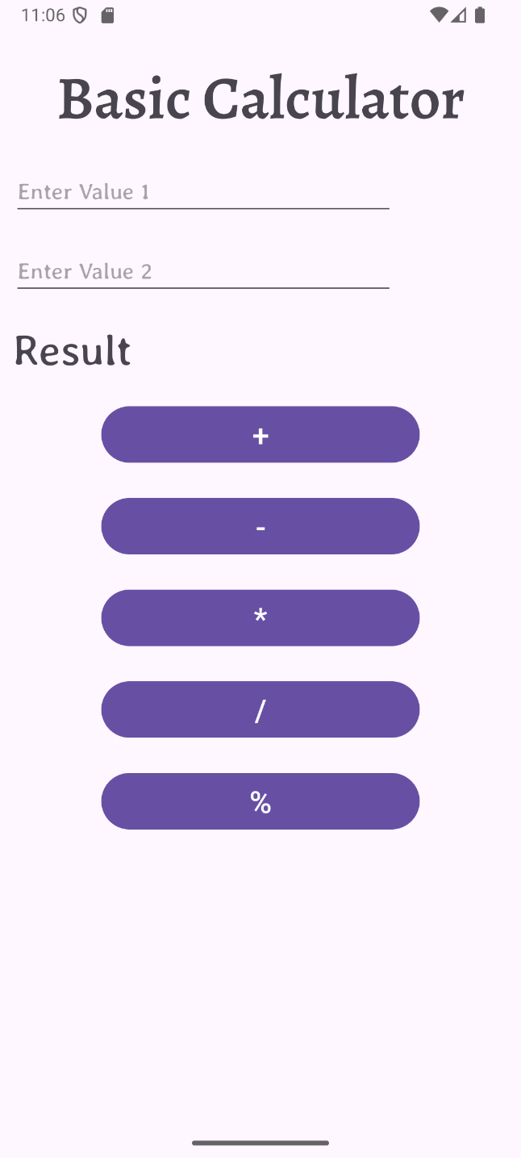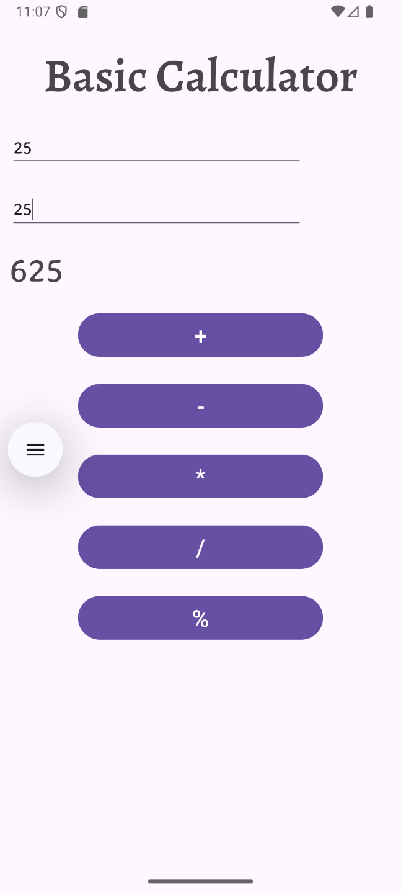
Result:
The basic calculator Android application was successfully developed and executed with correct arithmetic operations and output display.

